# [**‘Law & Order: Organized Crime’ Changes Showrunner Again**](https://www.tvinsider.com/1059100/law-order-organized-crime-changes-showrunner-again/)

[***Martin Holmes***](https://www.tvinsider.com/author/mholmes/)

SEPTEMBER 2, 7:59 AM

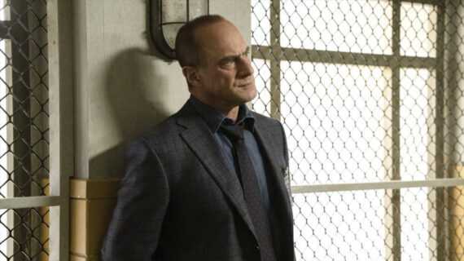

Virginia Sherwood/NBC

More changes are happening behind the scenes on [***Law & Order: Organized Crime***](https://www.tvinsider.com/show/law-order-organized-crime/) as the [**NBC**](https://www.tvinsider.com/network/nbc/) procedural is once again switching showrunners ahead of the third season.

Mais mudanças estão acontecendo entre as cenas em [***Law & Order: Organized Crime***](https://www.tvinsider.com/show/law-order-organized-crime/)enquanto o procedural da **NBC** está mais uma vez trocando de showrunners a frente da terceira temporada.

As reported by [***Deadline***](https://deadline.com/2022/09/law-order-organized-crime-sean-jablonski-replacing-bryan-goluboff-showrunner-1235106080/), Sean Jablonski is set to take over as showrunner for Season 3, just three months after [***Law & Order: SVU***](https://www.tvinsider.com/show/law-order-special-victims-unit/) veteran Bryan Goluboff took the reins. Goluboff had previously replaced Barry O’Brien, who was serving as interim showrunner after the departure of Ilene Chaiken in February. That means the show has been through four different showrunners in less than a year.

Como reportado por ***Deadline***, SeanJablonski está definido para assumir com showrunner para 3ª temporada, apenas três meses após veterano ***Law & Order: SVU*** Bryan Goluboff tomou as rédeas. Goluboff tinha substtiuido anteriormente Barry O’Brien, que estava servindo como showrunner interino após a partida de Ilene Chaiken em fevereiro. Isso significa que o show passou por quatro diferentes showrunners em menos que um ano.

Jablonski is perhaps best known for creating and producing the USA Network drama series [***Satisfaction***](https://www.tvinsider.com/show/satisfaction/), which aired for two seasons between 2014 and 2015. He’s also served as a writer and producer on shows such as *Project Blue Book, Gypsy, Suits*, and *Nip/Truck*. He also has previous ties to the [***Law & Order***](https://www.tvinsider.com/show/law-order/) franchise, having written and produced for the original series from 2001-2002.

*Organized Crime* premiered on April 1, 2021, and is the seventh series in the *Law & Order* franchise. It stars [**Christopher Meloni**](https://www.tvinsider.com/people/christopher-meloni/) as Elliot Stabler, reprising his role from *SVU*, alongside [**Danielle Moné Truitt**](https://www.tvinsider.com/people/danielle-mone-truitt/), [**Ainsley Seiger**](https://www.tvinsider.com/people/ainsley-seiger/), Brent Antonello, and Rick Gonzalez.

U,{576abfeb-b28a-462f-a0d1-460fe861a5f5}{164},3.125,2.0625[SEE ALSO](https://www.tvinsider.com/1057551/law-order-svu-organized-crime-premiere-crossover-2022-cast-case-date/)

### [**'Law & Order,' 'SVU' & 'Organized Crime' Officially Crossing Over for Premiere Event (VIDEO)**](https://www.tvinsider.com/1057551/law-order-svu-organized-crime-premiere-crossover-2022-cast-case-date/)

Get all the details, including in which order the three shows will air.

The upcoming third season premiere will be part of a franchise first, as all three of the [**Dick Wolf**](https://www.tvinsider.com/people/dick-wolf/) dramas on NBC will join forces in a special crossover event. *Organized Crime* will kick off the action at 8 pm on September 22 before the story continues on *SVU* and wraps up on *Law & Order*.

***Law & Order*–*SVU*–*Organized Crime* Crossover Premiere Event, Thursday, September 22, 8/7c, NBC**